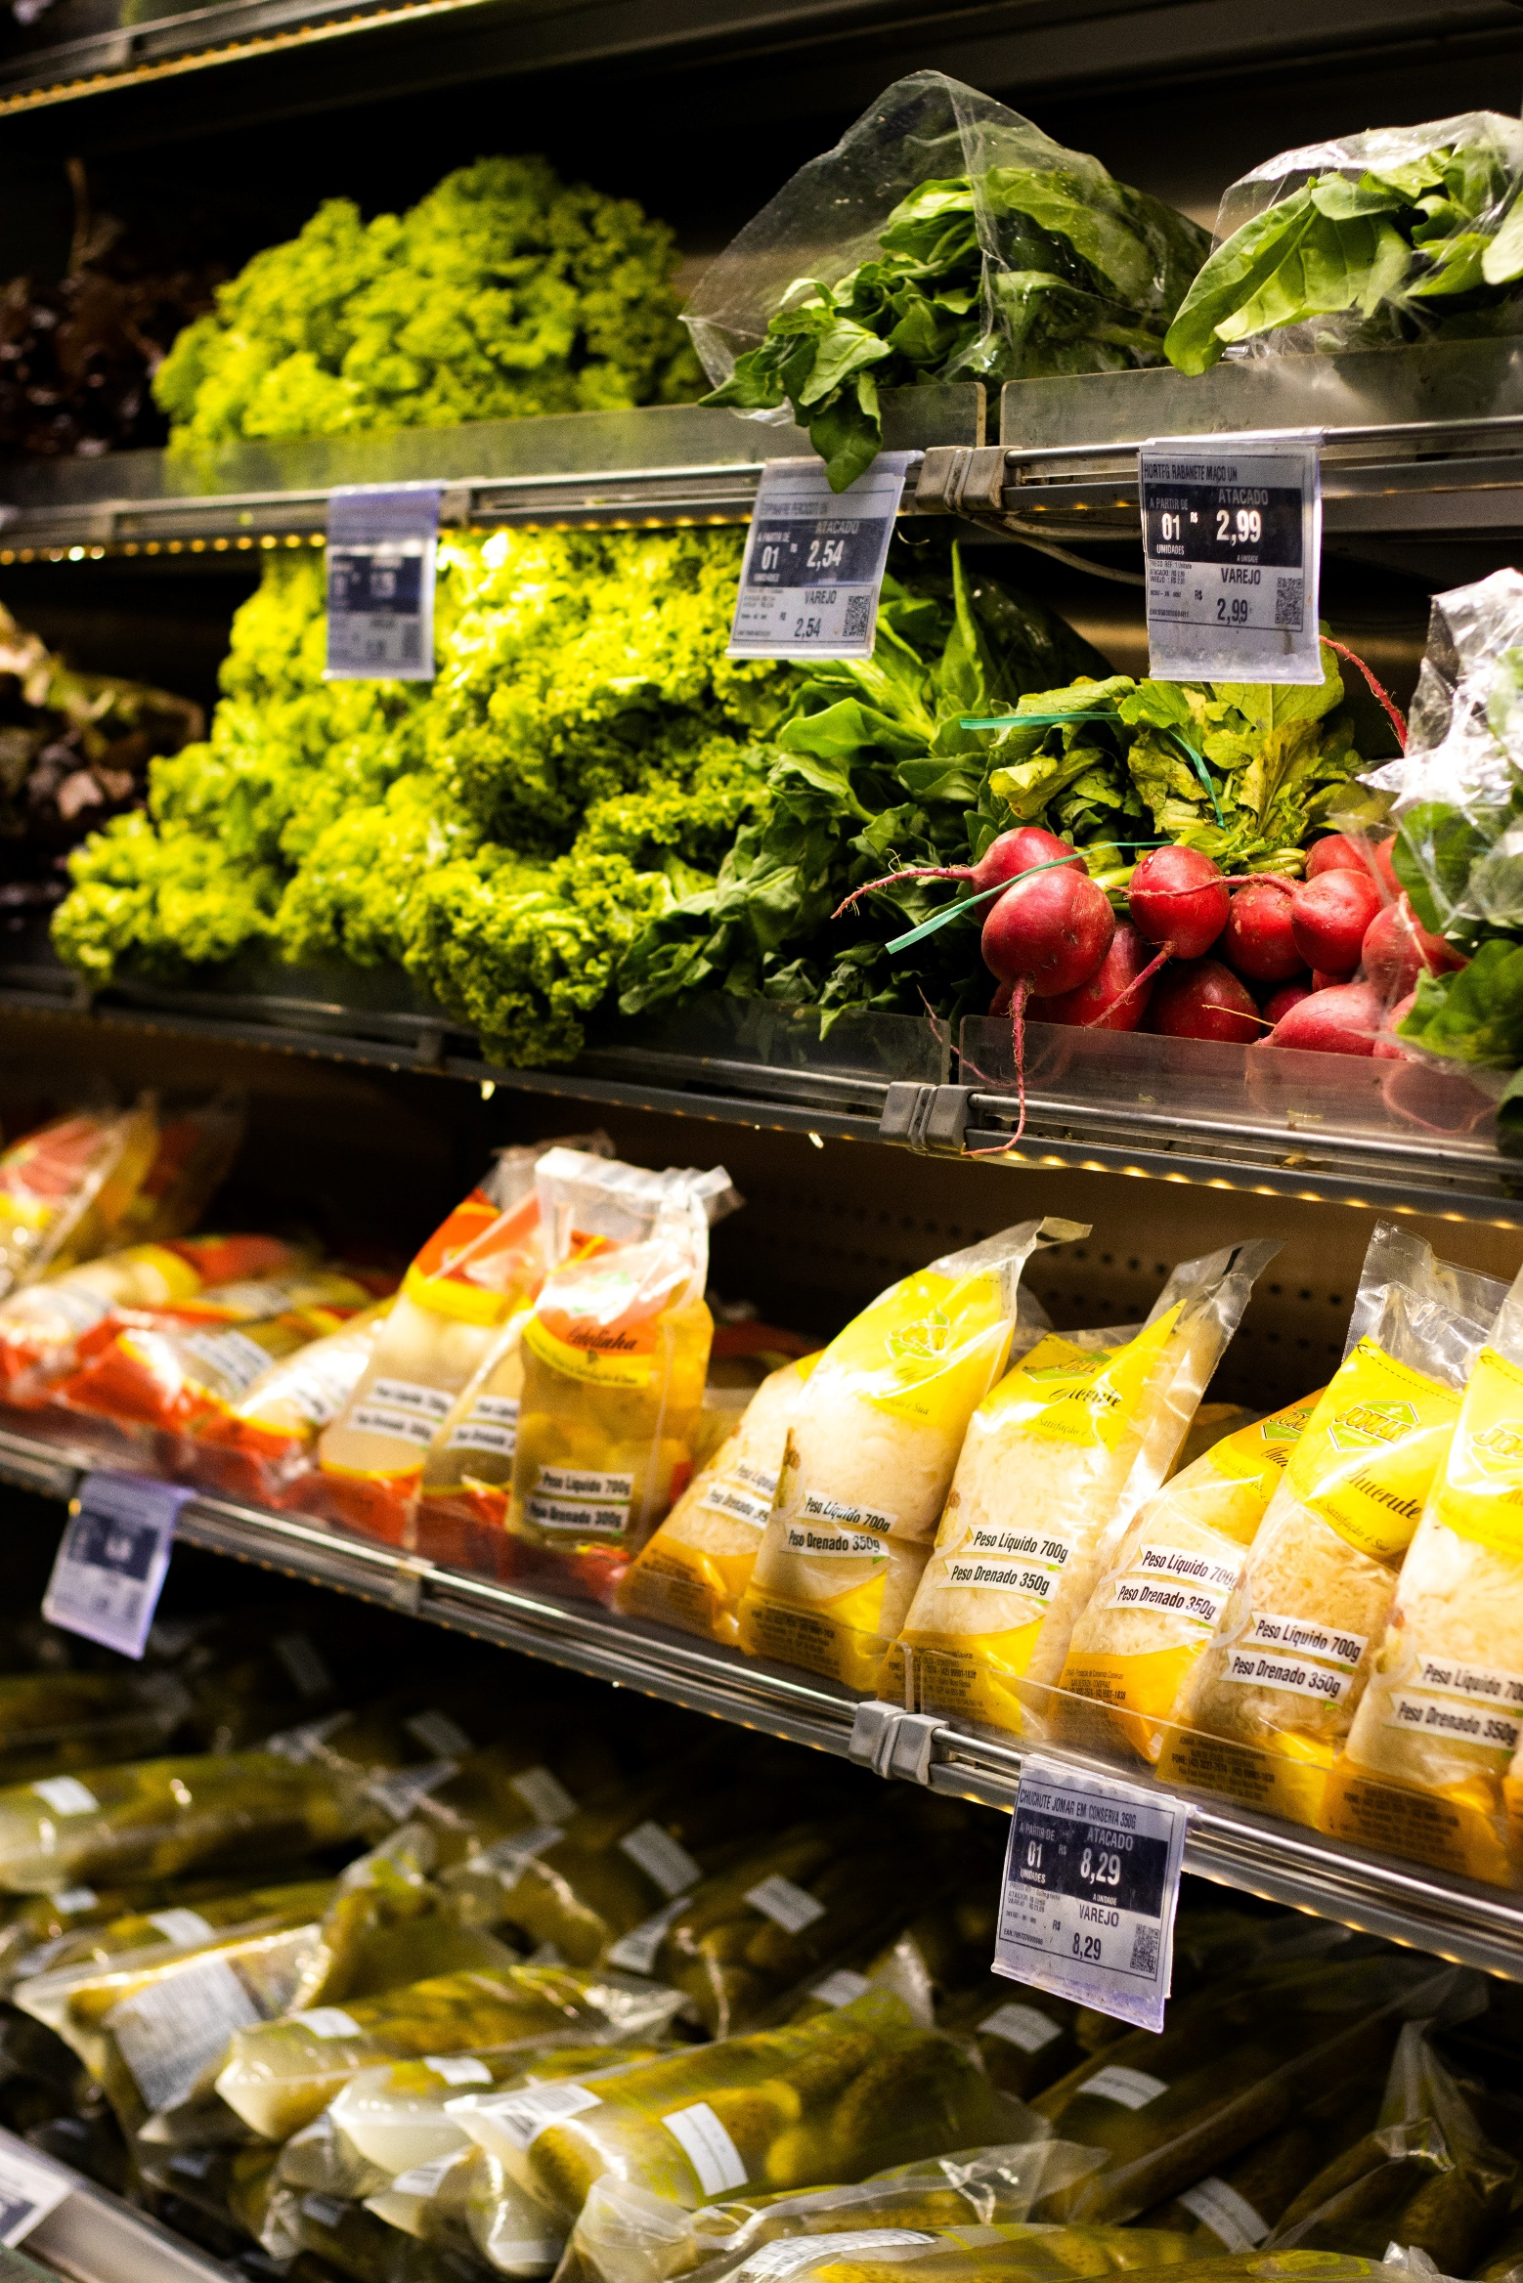

|  |  |
| --- | --- |
| Analysis of Supermarket requirements for medium sized Towns | |
| 4th October 2020 Alex Counihan  alex.counihan@hotmail.co.uk |  |

Contents

Executive Summary 3

Introduction 4

Data 4

Methodology 5

Data Gathering and Cleaning 5

Exploratory Data Analysis 6

Linear Regression 8

Results 9

Discussion 11

Conclusion 11

References 12

# Executive Summary

This report provides an analysis of Supermarkets within medium sized towns in the UK. It also evaluates whether it is possible to identify medium sized towns that have a requirement for Supermarkets that exceeds its current number of Supermarkets.

The research draws attention to a correlation of 85% between the number of Supermarkets within 7.5km of town centers and population within 12.5km of town centers. Of the 236 medium sized towns analyzed within this report 145 show their Supermarkets requirement as being higher than current figures while 91 show having a lower Supermarkets requirement than current figures.

Within the results section of this report is a map of the UK showing towns with a requirement above 0 as well as the top ten and bottom ten towns in the UK by Supermarket Requirements.

This report is limited by it not accounting for all towns and cities and not including GDP of these areas. Increased accuracy could also be attained by formalizing the definition of Supermarkets and splitting this category into Supermarkets and Convenience Stores. Further data validation is also recommended.

# Introduction

As of 2018 there were over 7000 supermarkets[1] in the UK. This high amount means there’s a lot of competition and that identifying the right place to open a new store is critical to its success.

This report is aimed towards identifying ‘Medium’ sized towns in the UK that have a below average amount of Supermarkets. As shown in Figure 1 a medium sized town is a town of a population 25000-59999.

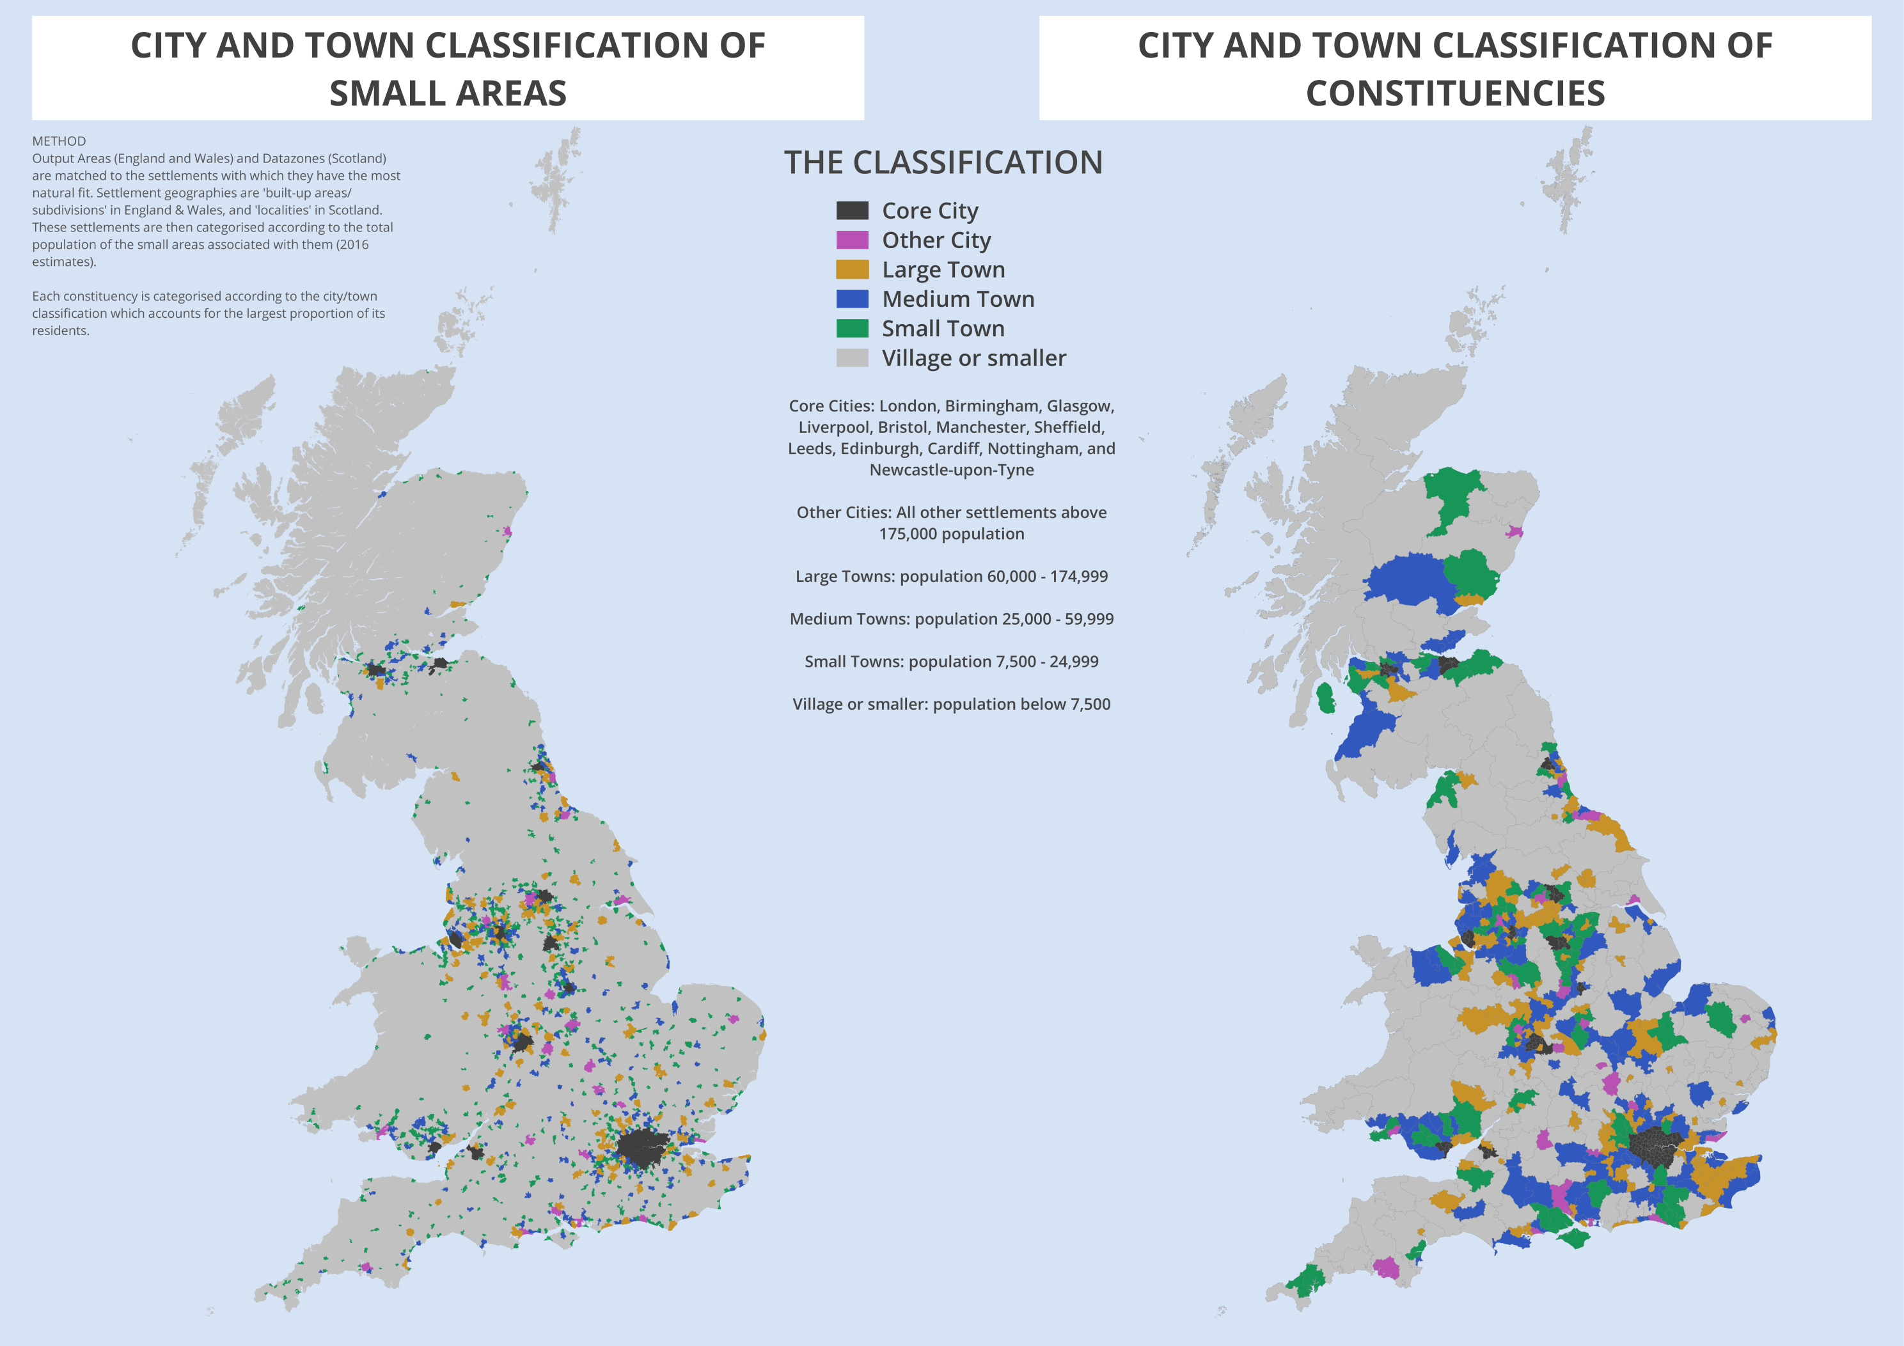

*Figure 1: Extract from UK Parliament City & Town Classification of Constituencies & Local Authorities[2]*

Within the foursquare API, a Supermarket is any shop that sells groceries as its primary stock. This includes but is not limited to Convenience Stores, Supermarkets and Cash and Carries. Other stores such as Takeaways, Fuel Stations and any store that primary purpose is not to sell groceries are excluded.

This report would be of interest to any party wanting to open a Supermarket within medium sized towns in the UK. This is because it will identify towns that are below the average Supermarkets per population count and therefore have less competition, which may increase footfall.

# Data

I will be using data from three different sources for this report. Firstly, population by town-city from the ONS (Office of National Statistics)[3]. This dataset contains all towns and cities in the UK as well as population by year from 2011 to 2019. The names will be used by our other data gathering methods to identify the locations of medium sized towns and the number of Supermarkets within them. The Population will be used to give a relative population per Supermarket, which will be required to identify an average and therefore what areas are below and above this average.

The second data set will be from ARCGIS API[4]. This will be to geocode town locations based off of their names, as gathered from the first dataset. With the latitude and longitude, we will be able to carry out a foursquare search for Supermarkets. This will also allow us to use range calculations to identify how many towns are within a

specified area of influence, and therefore assess where results may be skewed due to searches picking up stores within nearby towns or cities.

The final data set will be from the foursquare API[5]. This API allows us to search by category of venues with a certain distance of a location. With this we can look for all Supermarkets within a set area from the center of our ‘Medium’ sized towns. This will be critical for identifying the number of Supermarkets per population.

# Methodology

## Data Gathering and Cleaning

The first stage was downloading and carrying out initial analysis of the population by town-city data. The data initially looks as in Figure 2.

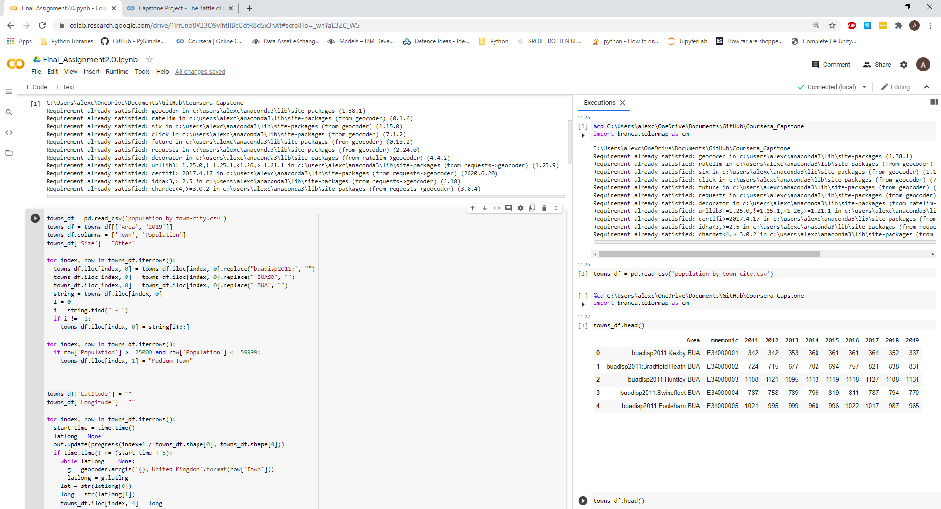

*Figure 2: The first 5 rows in the population by town-city dataset. The data is split by area, mnemonic and population by year.*

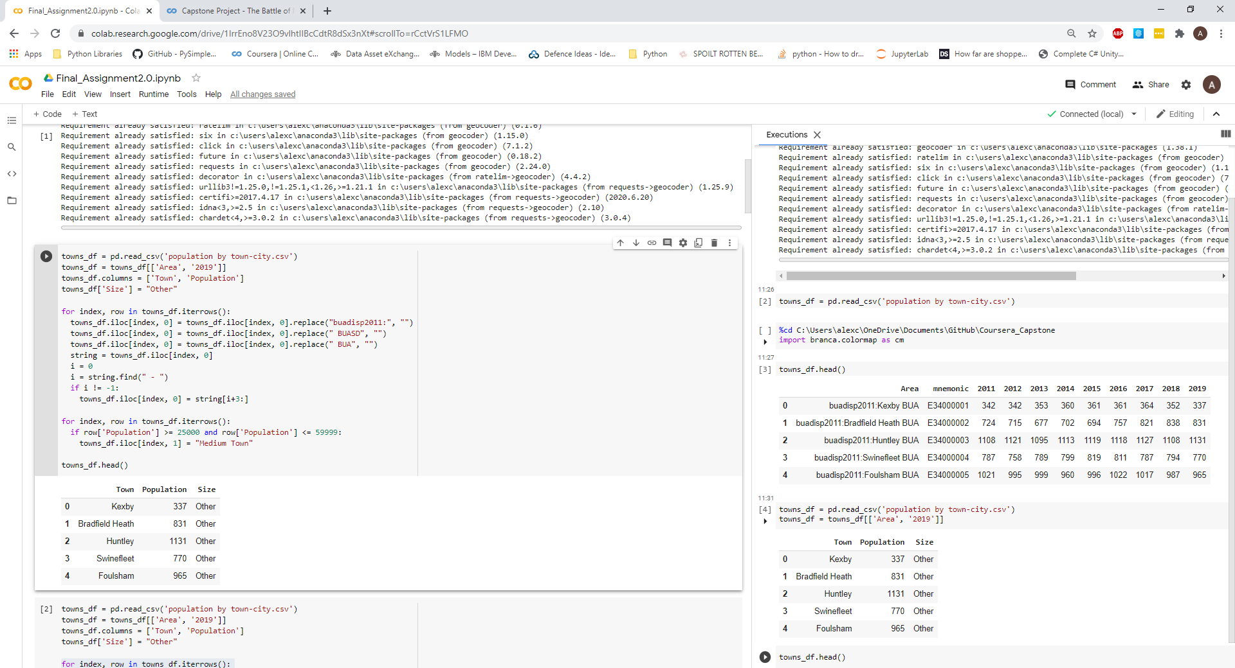By cleaning area and converting it into town, then removing all other columns except 2019, which we change to Population we are now ready to identify ‘Medium’ sized towns. As previously mentioned, a ‘Medium’ sized town is one with between 25000 and 59999 people. After processing this data, it now looks as figure 3.

*Figure 3: Classified towns by population and name*

The next step is to add the longitude and latitude of each location by Town Name. This is a lengthy process due there being over 6000 rows and the time requirement for the ARCGIS API to respond to requests. Once finished we now have the latitude and longitude for each town/city. The data is as shown in Figure 4.

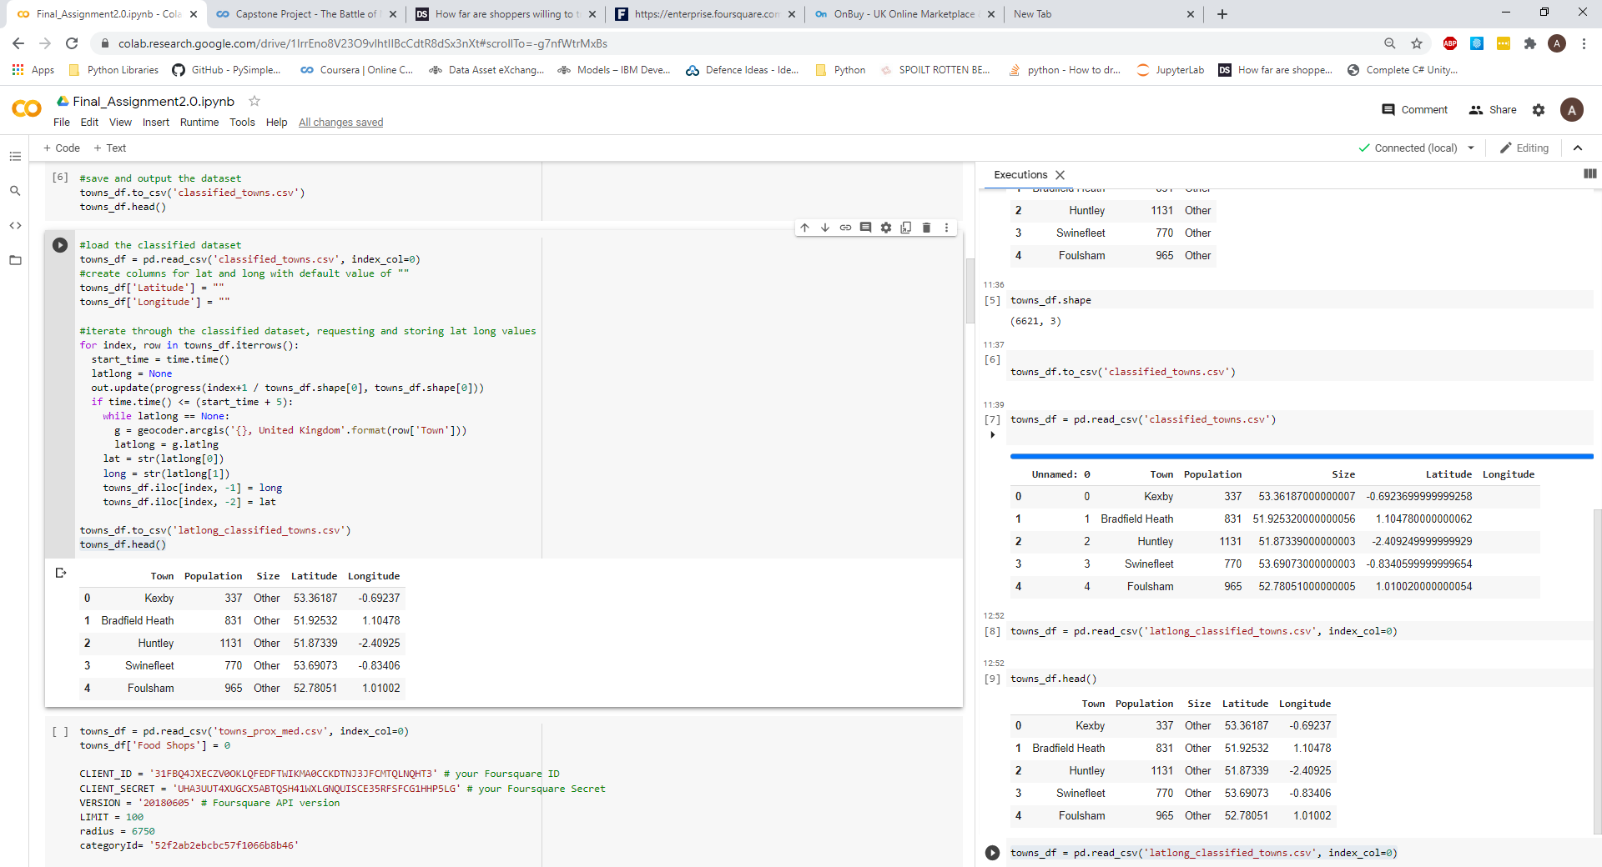

*Figure 4: Classified towns by population, name, location*

The final stage is to carry out a search of the locations to find the number of supermarkets within them. The foursquare API allows us to specify what we’re looking for, where we’re looking for it and what radius to search in. The category is passed in as the code for supermarkets and the location as the latitude and longitudes gathered in the previous step. For radius I decided upon 7.5Km, in an article about shopping by Dealer Support it states that a foursquare report says shoppers are willing to travel 9.4 miles during the majority of the year.[6] 7.5Km is half this distance, allowing for a 9.4-mile diameter. Once added data collection is completed.

## Exploratory Data Analysis

Now we have a dataset containing the following information: Town Name, Population, Size Category, Latitude, Longitude and Supermarkets. The idea is to plot Supermarkets against population and as they are towns within the same size category the hope is that they show strong correlation. As seen in Figure 5 this is not the case.

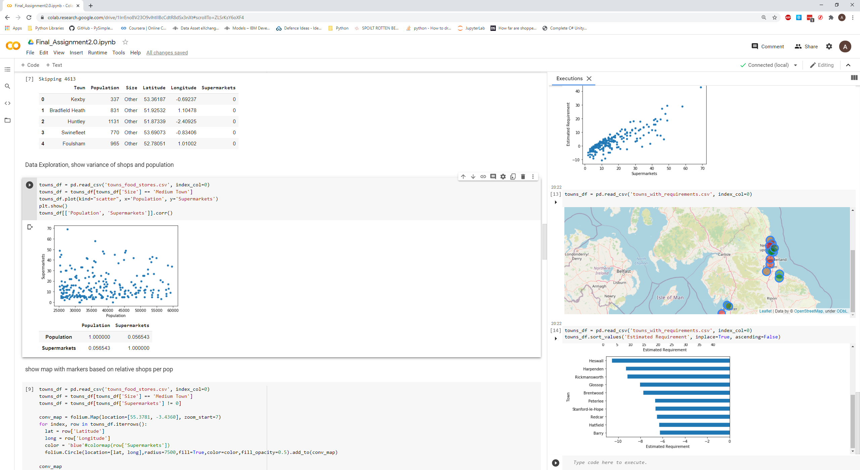

*Right: Figure 5: Top: Population vs Supermarkets for medium sized towns*

*Bottom: Correlation between Population and Supermarkets*

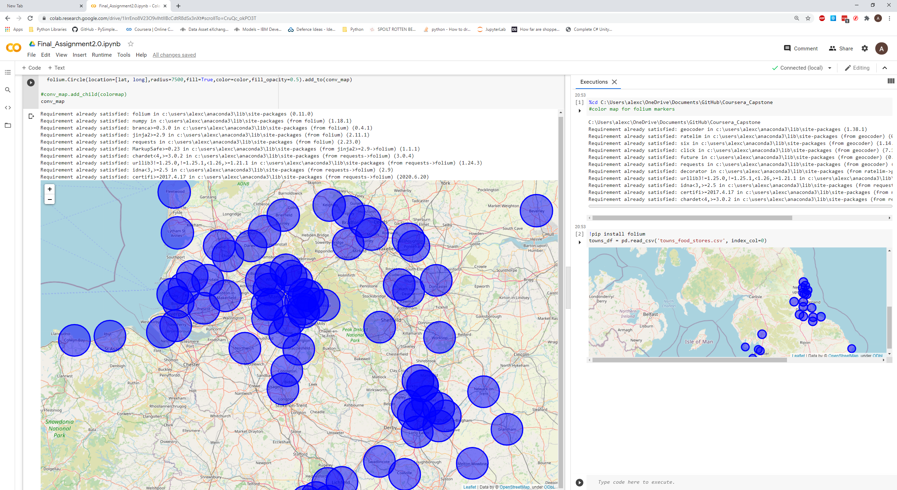As we can see there is only 5.6% correlation between Population and Supermarkets, and the scatter graph is very sparse accordingly. To see why this is happening I plotted the Towns with a circle marker within folium to see if there was any immediate reason for this. Figure 6 shows the results.

*Figure 6: Folium map showing all towns classified as ‘Medium Sized’ with their venue search radius as a circle marker.*

As we can see some of these towns are within several different search areas, which is skewing the results for these towns, while others are completely isolated. This is causing some towns to have much higher results than others for Supermarkets. To combat this, I checked all towns against the master towns list from the ONS and added an additional column to our dataset to account for populations of towns within a 7.5, 10, 12 and 15Km distance. Then I checked the correlation and plotted the data on a scatter graph. The results are shown at Figure 7.

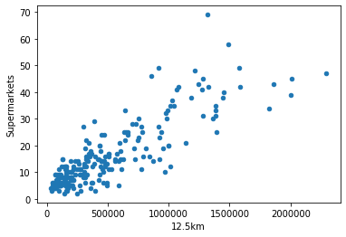

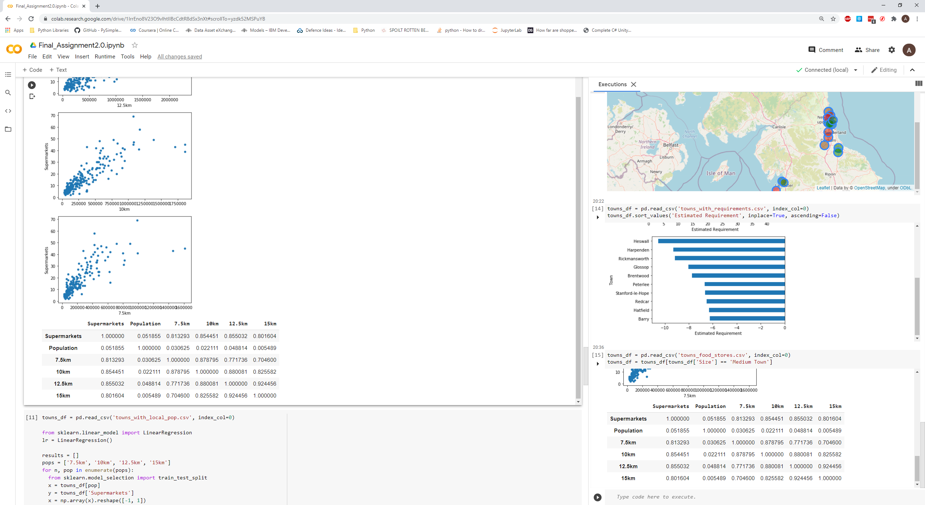

*Figure 7: Top: Scatter graph showing supermarkets vs population within 12.5km. Bottom: Correlation between Supermarkets and Population, Population within 7.5Km, 10Km. 12.5Km and 15Km*

There is a marked increase in correlation when taking into account the amount of people living in nearby towns. This peaks at 85% between 10 and 12.5Km. I will now add a line of best fit using linear regression. This will allow us to see what towns are above or below the average amount of Supermarkets per population range.

## Linear Regression

By splitting the dataset into 75% for training and 25% for testing we are able to assess the different population ranges and find what gives us the best overall result. Passing all 4 ranges in and then recording the R2 Score, Mean Absolute Error and Mean Squared Error. The results are at Figure 8.

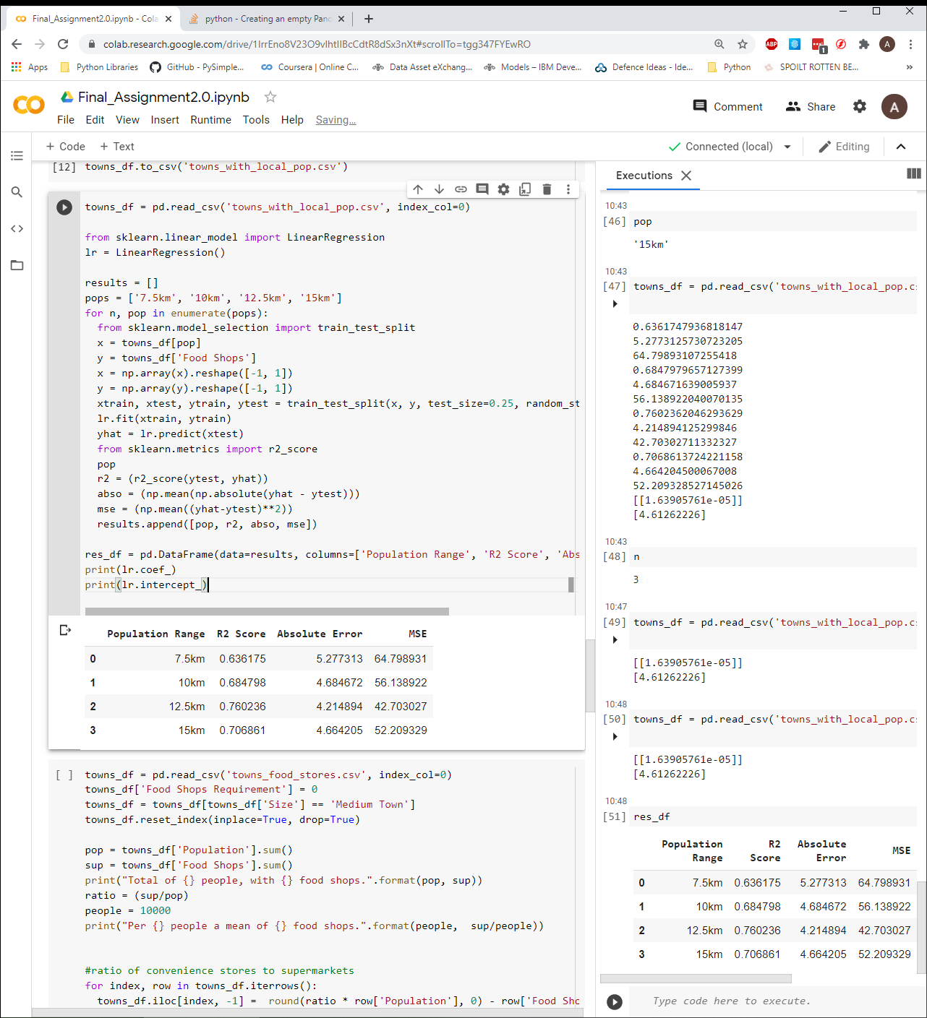*Figure 8: Results of creating linear regression models using the different population ranges.*

Previously at figure 7 we saw there was not much correlation difference between the ranges 10 and 12.5km. By looking at the scores in figure 8 we can see the 12.5km range out performs the other ranges, including 10km. 12.5km has the highest R2 Score and lowest Absolute Error and MSE.

By taking the coefficient and intercept of the model we can create a formula to apply to our towns with population ranges dataset in order to estimate a Supermarket requirement. The coefficient is 2.32975127e-05 and the intercept is 4.16254011. The formula we will apply is at figure 9.

$$y= α+ βx$$

Supermarkets = intercept + coefficient * Population within 12.5km

*Figure 9: Formula for estimating the Supermarket requirement.*

# Results

By applying the formula at figure 9 to our dataset and subtracting the resultant value from the current number of Supermarkets within each town we get a requirement value that is positive when more stores are estimated and negative when there are less stores required.

Once plotted we get the results at figure 10.

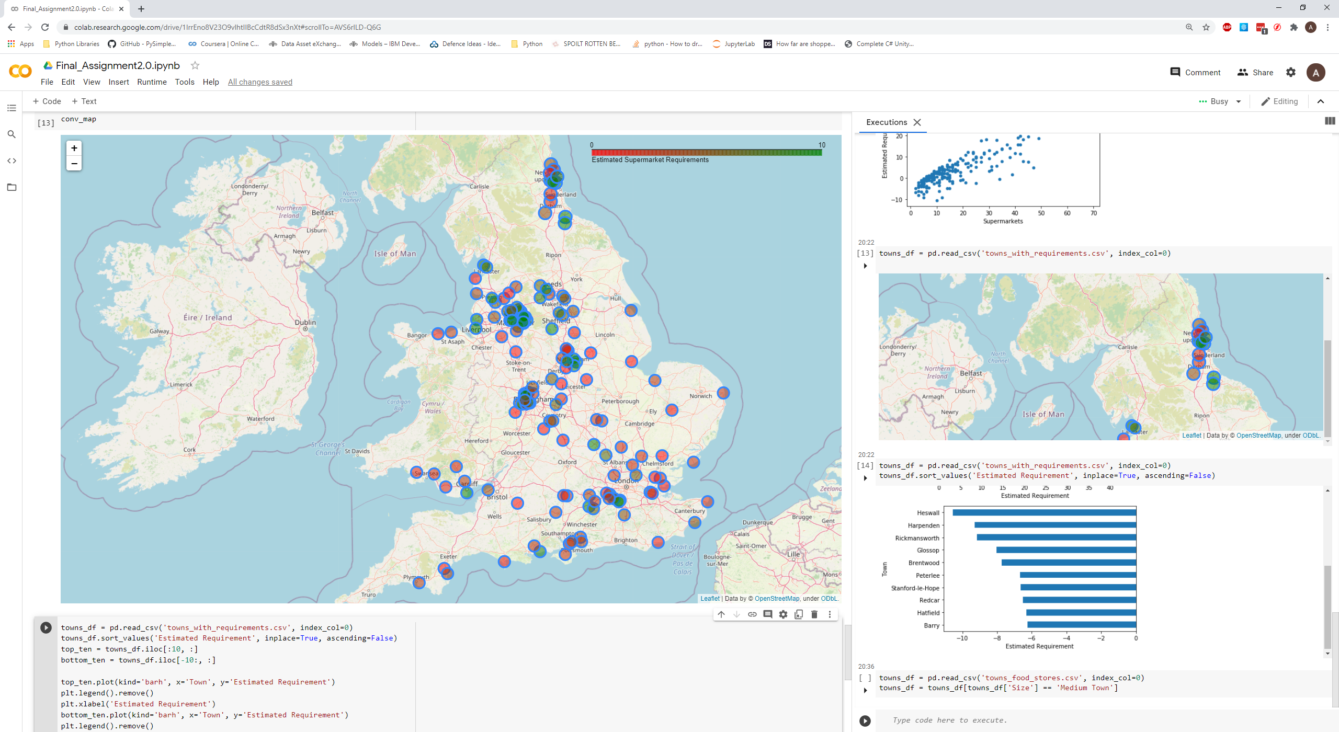

*Figure 10: Map view showing the relative requirements based on population within 12.5km*

We can see that now there are circles based on the radius which we previously determined as 7.5km due to customer travelling distances. Towns with a requirement below 0 are not show in order to prevent clutter. The higher the requirement the greener the circle.

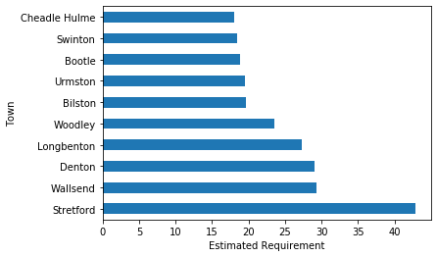

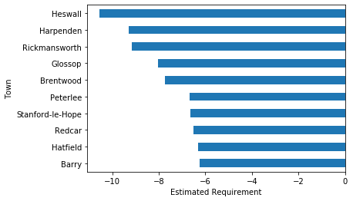

*Figure 11: Top: The ten towns with the highest requirement. Bottom: The ten towns with the lowest requirement.*

Figure 11 shows the ten towns with the highest and lowest requirements for Supermarkets.

# Discussion

From the analysis I have done it is possible to account for the number of Supermarkets required in a town based on the population within a specific radius, which includes other nearby towns.

By accounting for the nearby towns, I was able to increase the model accuracy by using data with much higher correlation (85% vs 5.6%). There are ways that I can see this being improved by further analysis. It is possible to drill down into the results from the foursquare API, which would allow for identifying the different types of Supermarkets i.e. Supermarkets and Convenience stores. Further verification would be required to ensure the accuracy of data. This could be done by running two separate venue searches from the foursquare API plus another API and validating the results against one another.

Even without this further analysis the results can be used to identify towns which are suitable for opening a new Supermarket in. Those that are either minus or close to zero should be avoided, while those of higher values are certainly worth further research.

# Conclusion

There is correlation between the nearby population and the number of Supermarkets that already exist. By exploiting this it is possible to increase the success of a new Supermarket, as it shows where there is lower competition and more potential shoppers.

Working on this research it would be possible to extend it to cover all types of town and city classifications. This would require careful testing to ensure the correct area of nearby towns population is included for any modeling.

By classifying types of Supermarkets as mentioned in the Discussion part of this paper it would be possible to identify what size Store would be ideal for a town, and possibly an estimation of how many shoppers each store type would be able to serve.

By utilizing the location data of stores around the UK and focusing the population searches by the store locations we could generate a choropleth map to visualize and identify areas with a high population to stores ratio. This would allow us to focus research and then precisely locate areas to build new stores.

# References

<https://www.statista.com/statistics/920074/number-of-stores-of-supermarkets-united-kingdom-uk/> - Amount of supermarkets in the UK

2 <https://commonslibrary.parliament.uk/research-briefings/cbp-8322/> - Classifications of towns sized from UK Gov

3 <https://geoportal.statistics.gov.uk/> - ONS site for downloading datasets

4 <https://developers.arcgis.com/> - ARCGIS API home site

5 <https://developer.foursquare.com/docs/places-api/> - foursquare places API

6 <https://dealersupport.co.uk/how-far-are-shoppers-willing-to-travel-during-the-festive-period/> - Study on the distances shoppers will travel

1.
2.
3.
4.
5.
6.